DocNo: 001.C.1:1

Requirement Analysis Document

Version 1.0

**Group Member:**

施宇

鲁皓

万成城

曹翼丰

**Document Language:**

English

Revision History

|  |  |  |  |
| --- | --- | --- | --- |
| **Date** | **Version** | **Description** | **Author** |
| 2015-11-16 | 1.0 | Finish the main structure of the document | 万成城 |
|  |  |  |  |
|  |  |  |  |

**Key Word**

Chinese chess, functional requirement, non-functional requirement

**Abstract**

This document defines most of the requirement for this system. It describes both functional and non-functional requirement. It also gives a specific hardware and software environment, and other necessary information for the system.

**Table of Contents**

1 Introduction 4

1.1 Purpose 4

1.2 Definition 4

1.3 Reference 4

2 System Overview 4

3 Detailed System Requirements 4

3.1 Functional Requirements 4

3.2 Non-Functional 4

3.3 Integration Requirements 4

3.4 Architecture Requirements 5

3.4.1 Computing Platforms 5

3.4.2 Environment Requirements 5

3.5 User Interface Requirements 5

4 Requirements Analysis Models 5

4.1 Functionality (behavioral) 5

4.1.1 Use Cases 5

4.1.2 Functional Analysis Model 5

4.2 Architecture & Bill of Materials 5

4.3 User Interface 6

5 Requirements Traceability 6

Introduction

## Purpose

This is a requirement specification document. The document defines most of the system requirement. The whole develop team can have a clear picture of the system. It defines both functional and non-functional requirement. This is the main document of this define phase, in this phase, we also have glossary document, use case specification document and we offer a prototype.

## Definition

AI: artificial intelligence

Functional requirement: requirement that need to be realized

Non-functional requirement: requirement that cannot be realized but is indispensable to the system

## Reference

*“Object-oriented Software Engineering, Using UML, Patterns, and Java, Third Edition”*

byBernd Bruegge and Allen H. Dutoit

System Overview

Main features of Chinese chess game:

1. Multi-players, including both AI and online players.
2. Multiple game modes.
3. 3D effect

Detailed System Requirements

## Functional Requirements

In addition to basic Chinese chess game function, the system should support 3D game scene, man-man and man-machine games, multiple game modes, including transportation mode and obstacle mode.

### Non-Functional

It should be robust, user-friendly, portable and extensible.

## Integration Requirements

Null.

## Architecture Requirements

### Computing Platforms

CPU: i5 1.3Ghz or better

Main memory:

Minimize: 1GB recommendation: 4GB

### Environment Requirements

Unity5 or above.

## User Interface Requirements

Details in 4.3.

Requirements Analysis Models

## Functionality (behavioral)

### Use Cases

This system is divided into five use cases:

1. Basic logic
2. Artificial intelligence
3. Network connection
4. Game mode
5. 3D effect

Each use case is specified in the use case specification document. Please refer to each use case specification document to get detail information to know more about each use case.

### Functional Analysis Model

Here is the view of use case model. It is created with Enterprise Architect.

WANCC:Use Case Model.pdf

## Architecture & Bill of Materials

|  |  |  |  |  |  |  |  |  |  |  |
| --- | --- | --- | --- | --- | --- | --- | --- | --- | --- | --- |
| Seq | Item | Qty | Functional Description | Vendor/ Manufacturer | Product  Name | Version | Part  No. | **P**urchase  **R**euse  **U**pgrade | Standard  **(Y/N)** | Remark |
| 1 | Development | High | Develop the system | Apple, America | Laptop | 1.0 | 10001 | R | N |  |
| 2 | Server | High | Provide network service, response all the request from the clients | IBM Rational, America | Desktop | 1.0 | 10002 | R | N |  |
| 3 | Operation System | High | Platform to develop system | Apple, America | Mac OS | OS X Yosemite | 10003 | R | N |  |
| 4 | UML tools | Middle | Design system | Sparx Systems, America | Enterprise  Architect | 2003 | 10004 |  | Y |  |
| 5 | Develop Environment | Middle | Integrated develop environment to develop system. | Unity Technologies, America | Unity | 5.0 | 10005 | R | Y |  |
| 6 | Office Tools | Middle | Edit documents, table, etc. | Microsoft,  America | Word, Excel, PowerPoint | 2011 Edition | 10006 | R | Y |  |

* If not a standard, indicates Standards Change Request #

## User Interface

The following picture shows the user interface of game mode choosing.



The following picture shows the user interface of chessing.

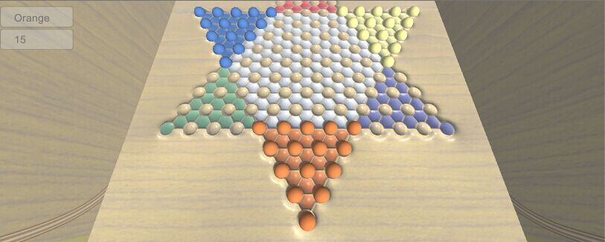

Requirements Traceability

In phase of developing, we will make three modules: Use-case Module, Analysis Module, and Design Module, so there exists the traceability among those modules.